**NSBM Green University**

Faculty of Computing

**PUSL2021- Introduction to IOT**

**Internet of Things (IoT) Group Project**

Project Initiation Document

|  |  |  |
| --- | --- | --- |
|  | Group Number | Group EE |
| Student ID (Plymouth) | Name (as appeared on DLE) |
| 1 | **10899603** | **Wedamulla Madusanka** |
| 2 | **10899621** | **Chathupraba Munasinghe** |
| 3 | **10899521** | **Badal Gamage** |
| 4 | **10899685** | **Kihaduwage Sahasra** |
| 5 | **10899600** | **Senanayake Liyanage** |
| 6 | **10899556** | **Yaddehi Kishal Sankalpa** |

|  |
| --- |
| Name: Navindu Nimsara Gamage |
| Student Reference Number: 10899521 |



|  |  |  |
| --- | --- | --- |
| Module Code: PUSL2021 | Module Name: Introduction to IOT | |
| Coursework Title: Project Initiation Document | | |
| Deadline Date:  10/11/2023 | | Member of staff responsible for coursework: Mr. Isuru Sri Bandara |
| Programme: BSc Hons Software Engineering | | |
| Please note that University Academic Regulations are available under Rules and Regulations on the University website [www.plymouth.ac.uk/studenthandbook](http://www.plymouth.ac.uk/studenthandbook). | | |
| Group work: please list all names of all participants formally associated with this work and state whether the work was undertaken alone or as part of a team. Please note you may be required to identify individual responsibility for component parts.  10899603 – Wedamulla Madinage Thisara Madusanka  10899621- Chathupraba Devindi Munasinghe  10899521 – Navindu Nimsara Gamage  10899556- Yaddehi Kishal Sankalpa Jayalath  10899685- Kihaduwage Diduli Wijini Sahasra  10899600- Senanayake Dasili Liyanage Sameepa Pramuditha  ***We confirm that we have read and understood the Plymouth University regulations relating to Assessment Offences and that we are aware of the possible penalties for any breach of these regulations. We confirm that this is the independent work of the group.***  Signed on behalf of the group: | | |
| Individual assignment: ***I confirm that I have read and understood the Plymouth University regulations relating to Assessment Offences and that I am aware of the possible penalties for any breach of these regulations. I confirm that this is my own independent work.***  Signed : | | |
| Use of translation software: failure to declare that translation software or a similar writing aid has been used will be treated as an assessment offence.  I *have used/not used translation software.  If used, please state name of software………………………………………………………………… | | |
| **Overall mark _____% Assessors Initials ______ Date_________** | | |

*Please delete as appropriateSci/ps/d:/students/cwkfrontcover/2013/14

Smart Bus Tracking Gadget

# Background:

Our team is starting an innovative journey to transform the public transportation experience in an era where connection and efficiency are crucial. Presenting our most recent project: the state-of-the-art GPS-enabled bus tracking gadget connected with a mobile application.

We realized the significance of seamless integration and real-time information in response to the changing requirements of contemporary commuters. Our bus tracking gadget is more than just a gadget it's revolutionizing the field of transportation administration. Our goal is to provide passengers a dynamic solution that surpasses conventional tracking systems by utilizing the power of GPS.

Our cutting-edge tool not only transforms the way we track buses but also goes above and beyond the call of duty. Our bus tracking equipment is fitted with cutting-edge sensors that can identify significant shocks and high temperatures in order to prioritize safety. The gadget instantly warns operators and pertinent authorities in the case of a sudden impact or extremely high temperatures. Our technology is unique in that it takes a proactive approach to safety, resulting in a secure environment for both passengers and the transportation infrastructure.

Imagine a commuter-friendly future where they can accurately anticipate arrival times, plan their trips with unmatched efficiency, and instantly track the exact position of their bus—all at their fingertips thanks to our user-friendly mobile app dashboard. With its abundance of features, this interface provides a thorough view of real-time tracking data and safety alarms.

Envision a world in which commuters can easily track the exact location of their bus, accurately forecast when they will arrive, and plan their routes with the highest level of ease. This gadget is the foundation of our all-inclusive bus tracking system, guaranteeing a seamless and coordinated experience for both passengers and operators.

Combining GPS technology with our dedication to innovation creates a wealth of opportunities. The list of benefits includes shorter wait times, better routes, and increased operational effectiveness. With our bus monitoring gadget, we are paving the path for the future of public transportation and demonstrating our commitment to developing solutions that genuinely improve people's lives.

# Literature Review:

Prior to starting our project, a detailed analysis of other people's approaches was done to see how other people had tackled the problems associated with bus tracking and GPS-based safety monitoring.

 A variety of techniques and approaches, from simple GPS tracking devices to more complex solutions, were examined. Understanding the technological nuances, data gathering techniques, and general architecture used in these systems was the main goal. This analysis shed important light on the advantages and disadvantages of each strategy.

A thorough examination of the outcomes produced by earlier solutions was done. This includes evaluating the systems' overall performance in real-world circumstances, as well as the tracking accuracy and safety alert efficacy. By digging into the specifics, we were able to have a thorough grasp of the results that various implementations produced.

Some inadequacies and holes were found by looking over and critiquing the solutions that were already in place. These can involve problems with the precision of real-time tracking, the speed at which safety alarms are responded to, or constraints on the systems' scalability. The identification of these gaps acted as a spur for the development of our initiative, which aims to tackle and resolve these issues.

As a summary, the examination of prior solutions entailed a thorough examination of techniques, strategies, and outcomes, culminating in a critical evaluation that identified deficiencies. Our project is built upon this fundamental study, as we want to present a novel solution that not only bridges the gaps in the current understanding but also strengthens it in order to produce a more reliable and efficient bus tracking and safety monitoring system.

# Aim:

This project is aimed at developing an innovative approach that combines real-time tracking with intelligent sensors to ensure a safe and effective public transportation experience. Our goal is to improve bus tracking and safety monitoring using GPS technology by filling in the gaps in accuracy and responsiveness.

# Objectives:

1. Provide a reliable GPS-based bus tracking system that can deliver real-time location data for effective administration of public transportation.
2. To improve safety monitoring, use clever sensors that can identify powerful shocks and high temperatures.
3. Consolidate the safety monitoring and bus tracking functions into a streamlined, intuitive mobile app dashboard that is accessible to both operators and passengers.
4. To reduce wait times and improve route planning, make sure the real-time tracking data on the mobile app dashboard is accurate and dependable.
5. Provide a fluid and intuitive user experience for operators and passengers by integrating the safety monitoring and bus tracking components into one interface.
6. To reduce wait times and improve route planning, make sure that real-time tracking information is accurate and dependable.
7. Provide a safe and effective alarm system that, in the case of a powerful shock or excessive temperature, rapidly alerts operators and pertinent authorities.
8. To guarantee the efficacy and dependability of the integrated system, thoroughly test and validate it in real-world situations.
9. To ensure the bus tracking and safety monitoring system is adopted and maintained smoothly, provide thorough documentation and training materials.
10. Maintain the system's relevance and sustainability by iterating and improving it continuously in response to user input and new developments in technology.

# System Overview:

The system will make use of sophisticated sensors that can distinguish between extreme heat and powerful shocks. It is imperative that these sensors possess high accuracy, durability, and compactness to guarantee precise data collecting.

We use an embedded computer system to guarantee processing in real time and effective integration with the sensor network.

In order to extract pertinent information, such as temperature anomalies or the intensity of shocks, the embedded system must process sensor data in real-time. It will also make it easier to include this processed data into the broader safety monitoring and bus tracking system.

The embedded system will be in communication with sensors and Internet of Things (IoT) devices via a wireless network, making use of 4G/LTE and Wi-Fi technologies for seamless connection. After processing, the data will be sent via the internet to a server or cloud, guaranteeing a steady and dependable flow of data.

Using a safe and expandable storage method, sensor data will be kept on cloud servers. We see an efficient organized database system that stores and arranges the data for later review and examination.

A thorough examination of the gathered data will be performed to find trends, patterns, and anomalies. In addition to improving safety features, this study will help guide route optimization tactics and boost system performance.

Our method for developing interfaces includes making a mobile app dashboard that is easy to use for both passengers and operators. This interface will make it easier to administer and configure while seeing safety warnings and real-time bus tracking data. To ensure a smooth user experience when controlling and monitoring the transportation infrastructure, the design will place a high priority on simplicity and intuitiveness. Serving as a central hub, the mobile app dashboard will give users quick access to vital information and facilitate effective communication with the bus tracking and safety monitoring system.

# Expected Outcome:

The ultimate goal is to provide a fully functional and smooth public transportation system that includes a mobile app dashboard, smart safety sensors, and a GPS-based bus tracking system. Through proactive safety alerts, real-time tracking, and an easy-to-use interface for both operators and passengers, this solution seeks to prioritize safety, maximize operational efficiency, and improve the passenger experience.

# Grant Chart

Milestone 1: Design and Architecture of the System

Time Period: 10 Days

Create the system's architectural foundation, considering the mobile app dashboard, intelligent sensors, and GPS tracking integration.

Milestone 2: Testing and Integrating Sensors

Time Period:

Obtain and include clever sensors into the system; carry out exhaustive testing to guarantee precise data gathering and processing in real time.

Milestone 3: Testing and System Integration

Time Period: 1-2 Months

Complete system integration and rigorous testing are necessary to guarantee correctness, dependability, and interoperability in practical situations.

Milestone 4: Optimization and Refinement

Time Period: 2 Weeks

Refine and optimize the system, resolving any problems or improvements found, based on testing input and test results.

Milestone 5: Complete Implementation

Timeline: 3 Weeks

When the system is completely optimized, it will be deployed on a large scale with little disruption to current operations and a seamless transition.

Milestone 6: Updates and Constant Improvement

Time Period: In progress

To improve the functionality and efficiency of the system, implement a continuous improvement cycle that takes user feedback into account, addresses new technical developments, and releases updates on a regular basis.

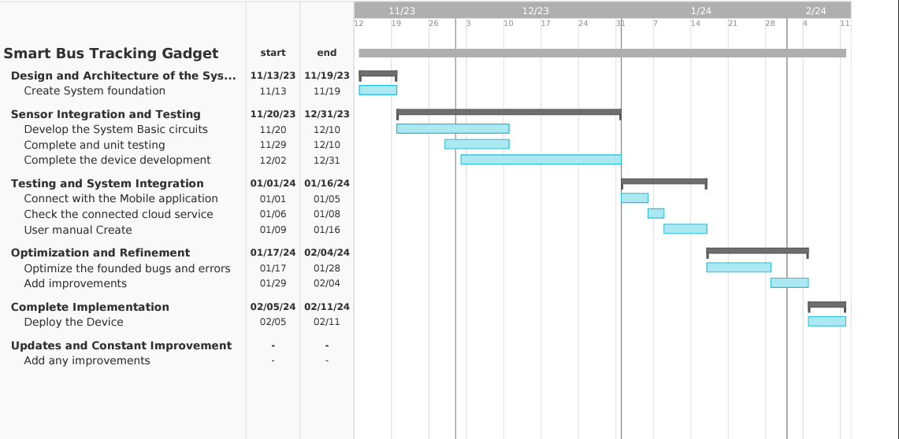

# References:

Alquhali, A.H. *et al.* (2019) ‘IOT based real-time vehicle tracking system’, *2019 IEEE Conference on Sustainable Utilization and Development in Engineering and Technologies (CSUDET)* [Preprint]. doi:10.1109/csudet47057.2019.9214633.

‘IOT based real-time Autonomous Vehicle Tracking System’ (2017) *International Journal of Modern Trends in Engineering &amp; Research*, 4(10), pp. 174–179. doi:10.21884/ijmter.2017.4324.lwba6.

‘Real time vehicle monitoring and tracking system for school bus via Beagle Bone’ (2015) *International Journal of Science and Research (IJSR)*, 5(5), pp. 918–921. doi:10.21275/v5i5.nov163489.

*IOT based vehicle tracking system using GPS* (no date) *FreeProjectz*. Available at: <https://www.freeprojectz.com/iot-arduino-projects/> vehicle-tracking-system-gps (Accessed: 09 November 2023).

Smith, A. (2022) *The benefits of an IOT-based vehicle tracking system*, *Medium*. Available at: <https://web-and-mobile-development.medium.com/> the-benefits-of-an-iot-based-vehicle-tracking-system-9581a27354ff(Accessed: 09 November 2023).

# Group Contribution:

|  |  |  |  |
| --- | --- | --- | --- |
|  | **Plymouth ID** | **Name (As appeared on DLE)** | **Contributed section** |
| **1** | **10899603** | **Wedamulla Madusanka** | **Finalize the Documentation and Explore through the similar Projects on Web** |
| **2** | **10899621** | **Chathupraba Munasinghe** | **Study about Strong Vibration identity System and gather Information** |
| **3** | **10899521** | **Badal Gamage** | **Scope the project idea and study about the exiting devices like project idea and study about GPS** |
| **4** | **10899685** | **Kihaduwage Sahasra** | **Study the Mobile application and features** |
| **5** | **10899600** | **Senanayake Liyanage** | **Explore and study about the high temperature Alert System** |
| **6** | **10899556** | **Yaddehi Kishsal Sankalpa** | **Study and explore about GPS system and gather facts** |